Lab Test 02

# BSc (Hons) in Information Technology

Year 2



IE2031 – Structured Analysis and Design Semester 1, 2019

IT17103978 – Liyanaarachchi L.A.S.S

IT17533942 – Jayana Gayathri D.M

a)

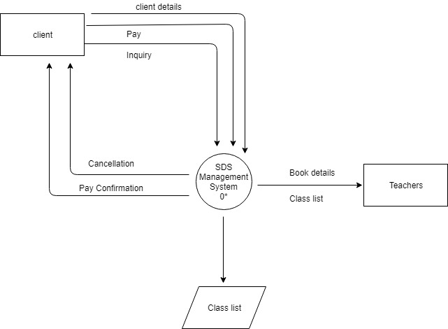

b)

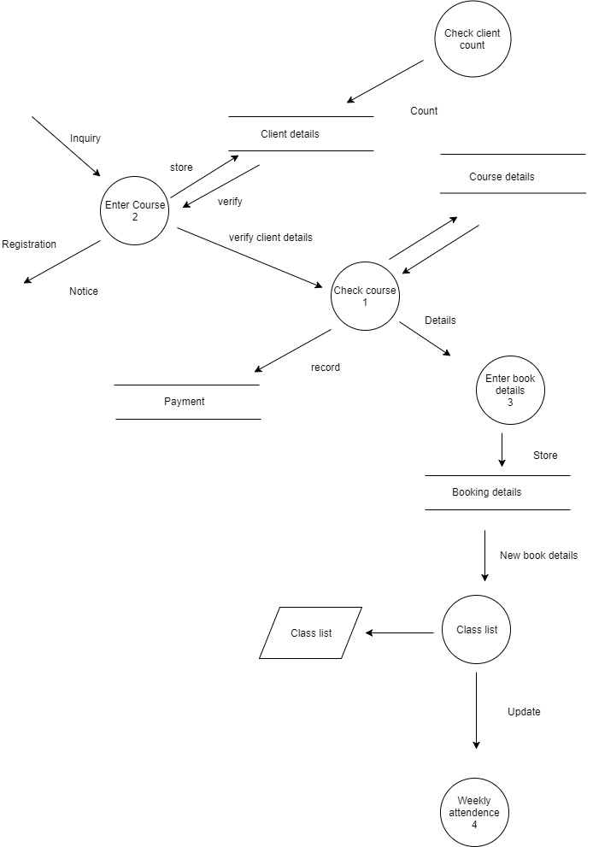

c)

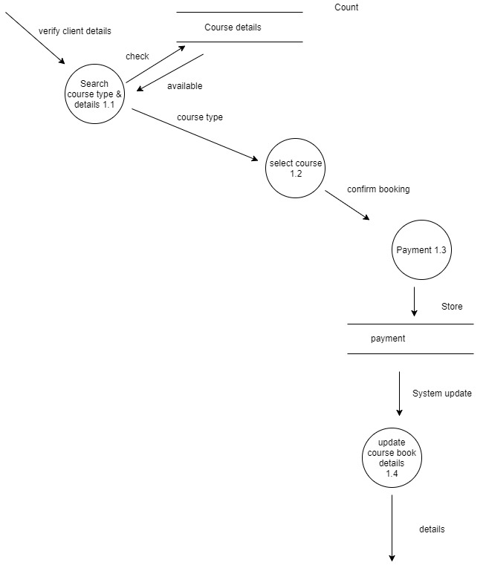

d)

Inquiry = Name + Address + Phone Number + email address (client details)

Cancellation = contact the clients to notice Cancellation

Book details = Class list

Pay = Customer Payment

Details= confirmed course details

e)

